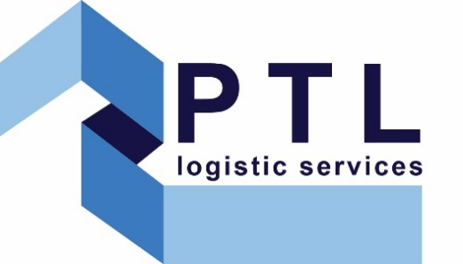

Modern Slavery Statement

Introduction
PTL Logistic Services Ltd is committed to preventing acts of modern slavery and human trafficking from occurring within its business and supply chain, and imposes the same high standards on its suppliers. Slavery and human trafficking is an issue which can affect global businesses. Recognising this, PTL Logistic Services Ltd makes every effort to ensure each employee remains vigilant against the associated risks in our business and in the wider supply chain, regardless of the size of the threat. We have implemented appropriate measures across the business to ensure best practice around issues with pose a threat to human rights. It is expected that all of our colleagues report incidents of concern, and these are then addressed appropriately by our management team.

Structure of the Organisation
PTL Logistic Services Ltd is an award-winning temporary recruitment specialist in the construction sector. We work primarily in the UK and employ 5 recruitment specialists in our London office. Paramount Trades & Labour works to improve standards in the recruitment industry and stands for the best in specialist, professional and proactive recruitment.

Supply Chain Overview
The recruitment sector’s supply chain can be complex particularly for international engagements. PTL Logistic Services Ltd predominantly works in the UK on UK-based assignments, minimising this risk. We work with a supply chain that includes contractors, suppliers and professional consultants. PTL Logistic Services Ltd are committed to effectively managing their supply chain to ensure human rights are wholly respected.

Supply Chain Standards and Process
As part of our commitment to combating modern slavery PTL Logistic Services Ltd regularly evaluates the nature and extent of its exposure to the risk of modern slavery occurring in its supply chain. In our standard terms of business with both candidates & clients, PTL Logistic Services conveys its commitment to the prevention of slavery and human trafficking.

Prior to conducting business with any client or third party company, appropriate due diligence and compliance checks are completed to ensure no relationship is formed with parties who have a history of transgressions around human trafficking and modern slavery. Furthermore, any parties in PTL Logistic Services Ltd’s supply chain who are subsequently discovered as having partaken in such offences have their business relationship terminated without notice or delay.
Our due diligence procedures are designed to:
- Establish and assess areas of potential risk in our business and supply chains
- Monitor potential risk areas in our business and supply chains
- Reduce the risk of slavery and human trafficking occurring in our business and supply chains
- Provide adequate protection for whistle-blowers

Risk and Compliance
We recognise that construction is deemed to be a high risk sector for modern slavery and human trafficking and that risks exist in procurement processes (for works, services, goods and materials), recruitment practices and site management. Projects often include a large number of contractors, including lower skilled trades which increased the potential risk of labour exploitation.
We require that all those in our supply chain comply with our values. We enforce a strict code of compliance and do not tolerate slavery or human trafficking within our supply chains. None of our supply chain have identified any concerns about compliance with our anti-slavery policies in this financial year.

Training
As a standard practice, PTL Logistic Services Ltd recruitment consultants communicate with potential candidates on an entirely direct basis. We do not accept communicating through an intermediary. Not only does this prove a far more efficient method of identifying the ideal candidate in the timeliest of fashion, but it provides PTL Logistic Services Ltd with crucial direct contact with the candidate, therefore giving additional comfort that PTL Logistic Services Ltd has no exposure to the risk of modern slavery occurring in its supply chain.
We regularly conduct training for our sales teams so that they understand the signs of modern slavery and what to do if they suspect that it is taking place within our supply chain.

Statement
This statement is made pursuant to section 54(1) of the Modern Slavery Act 2015 and constitutes PTL Logistic Services Ltd slavery and human trafficking statement for the current financial year.

________________________________________________________________________________
Dated: 30 April 2026
Review date: 30 April 2027

Signed:

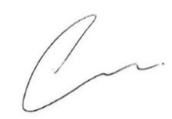
Darren Campbell
Managing Director

